# 

# **Department of Computer Science and Engineering Islamic University of Technology (IUT)** A subsidiary organ of OIC

# **Laboratory Report**

# CSE 4412: Data Communication and Networking Lab

## 

## **Name: Rowshan Mannan Oni Student ID: 210042145 Section: SWE Semester: Winter(4th) Academic Year: 2022-2023**

**Date of Submission: 27/03/2024**

### **Title:** Configuring Switch Port Security and Switch Port Analyzer (SPAN) in Cisco Devices

### **Objective**:

### Describe the concept of Switch Port Security

### ● Explain importance of Switch Port Security in securing an organization

### ● Configure Switch Port Security in CISCO devices

### ● Use Switch Port Security feature to achieve varying degrees of protection

### ● Describe the concept of port mirroring

### ● Implement port mirroring using Cisco Switch Port Analyzer (SPAN)

### **Devices/ software Used**:

* + - 1. Cisco Packet Tracer

### **Theory:**

**Port Mirroring:**

Port mirroring, also known as port monitoring or port spanning, is a feature found in managed switches. It allows you to copy the traffic that flows through one or more ports (the source ports) and send it to another port (the destination port), where it can be analyzed by a monitoring device such as a network analyzer, intrusion detection system (IDS), or packet sniffer.

**Local SPAN:**

Local SPAN is a type of port mirroring that captures network traffic within a single switch. In Local SPAN, you configure the switch to copy traffic from one or more source ports and forward it to a designated destination port for analysis**.**

### 

### **Diagram of the experiment(s):**

*(Provide screenshot of the final network topology. Make sure to label the network components.)*

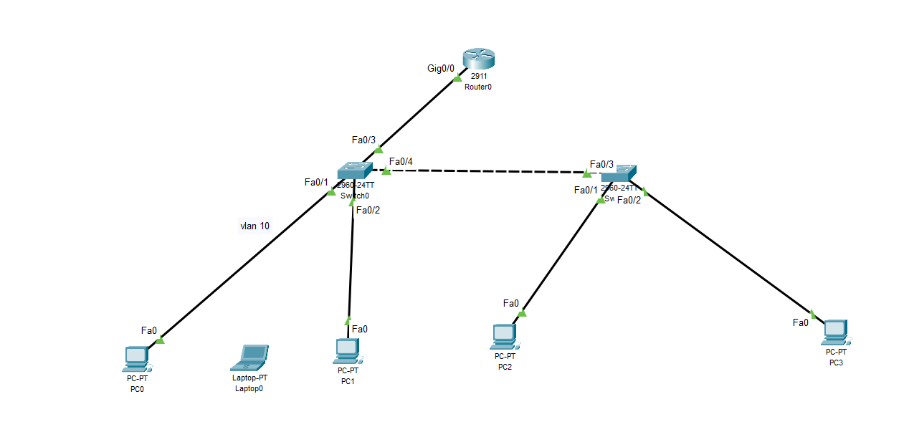

### **Working Procedure:**

***(****Explain in brief how you completed the tasks. Provide necessary screenshots of used commands for each task.)*

Firstly I implemented ***router-on-a-stick*** and created two vlans (vlan 10 and vlan 20).

Now I’ve written the following commands for both the routers to secure their respective interface. For example: below is the command for int f0/1.

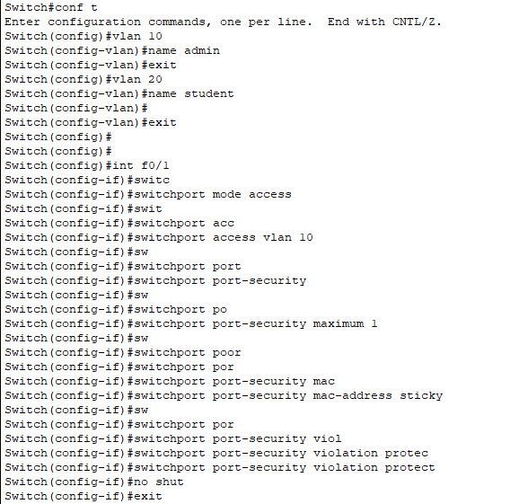

Similarly, we will do this for every other access link.

Now One thing to remember that I’ve given protect to admin and restrict to student1 , teacher and student2.

***task 2:***

Now for task 2, I’ve just written two lines of command so that admin can see what student 1 is upto:

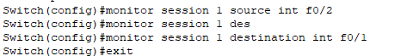

### **Observation**:

I’ve observed that if I use protect it won’t increase the violation count but if I use the port-security (RESTRICT). It will increase the violation count.

### **Challenges (if any):**